**Girls Inc. of Lynn presents**

**Bold Futures**

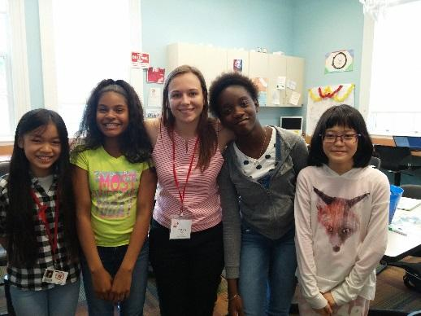**Middle School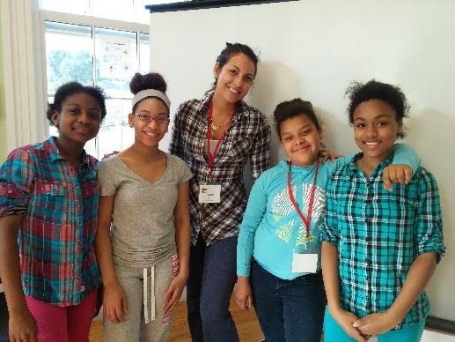 Group Mentoring Program**

**Mentoring Program Snapshot:**

November to June

1 hour a week   
(5 - 6pm)

Group mentoring

1:4 ratio (1 mentor and   
4 middle school girls)

Girls in grades 6, 7, 8

Site-based at Girls Inc.

Girls Inc. provides all activity supplies.

For more information, please contact:

**Lena Crowley**

[**lecrowley@girlsinclynn.org**](mailto:lecrowley@girlsinclynn.org)

**781-854-6733**

We are looking for women **MENTORS**  
to meet with a small group of girls each week for 1 hour to build positive relationships, have fun and help inspire our girls to be strong, smart and bold.

**Did you know?** ***64%*** *of students who have a mentor develop a more positive attitude towards school.*

**Mentoring Matters!**

The Bold Futures middle school mentoring program was created to provide additional academic and social support to middle school girls as they learn to navigate more demanding academics, get along with others and develop a positive attitude towards the community and school.

**Apply Here**

<https://forms.gle/gdW2tBchR4gLxVdo6>

**Activities include:**  
Knitting/sewing  
Painting and drawing  
Fun science experiments Do-it-yourself spa day  
Bracelet making  
Board games  
Cooking & baking  
Tie-dye  
Making crafts