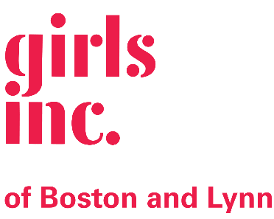

JOB TITLE: Career Readiness Specialist

DEPARTMENT: Middle and Teen Programs

PROGRAM: Career Path

REPORTS TO: Project Accelerate Supervisor

SUPERVISES: Volunteers

OVERVIEW: The Career Readiness Specialist will develop and implement a comprehensive career preparation programming for girls entering grades 9-12 which will include weekly workshops, monthly career panels, field trips to local companies, job shadows and internships.
STATUS: Part-time, non-exempt

RESPONSIBILITIES for the Career Readiness Specialist:

- Plan and deliver weekly career preparation workshops sessions to high schoolers in grades 9-12;
- Recruit, interview, and orient girls for program through schools, partner organizations and social media;
- Recruit and support career panelist volunteers and guest workshop presenters;
- Identify host sites for job shadows and externships;
- Establish annual program calendars and schedule;
- Evaluate and track program outcomes and outputs and report on the following: number of girls served, activities/events provided, change in the girls’ knowledge, skills and attitudes related to their future outlook, career awareness and job readiness skills;
- Complete all program reports as requested;
- Assist with grant applications and program budgets;
- Carry out other duties as assigned, including preparing and serving snack and assisting with specialist events;
- Work collaboratively with other Girls Inc. staff to provide a safe, secure, pro-girl environment.
- Establish and maintain partnerships with area agencies, businesses, and schools as well corporate partners.

QUALIFICATIONS for the Career Readiness Specialist:

- Bachelor’s degree preferred however college students are encouraged to apply and work experience is also highly valued;
- Two years of experience with adolescents;
- Experience developing engaging, relevant programming;
- Experience in group facilitation;
- Excellent organizational, written and verbal communication skills;
- Experience with report writing;
- Familiar and comfortable working with volunteers and other community partners;
- Ability to work as an effective and active team player;
- Demonstrated ability to work with adults and youth of different races, ethnicities, ages, abilities and experiences;
- Able to work flexible hours including evenings, and the occasional weekend;
- Bi-lingual a plus, preferably Spanish/English Speaking;

Rate: $20.83 per hour
Hours: 20 hours per week, Monday-Friday 2:00-6:00 PM
Benefits: Paid holidays and earned time

Girls Incorporated of Lynn is an Equal Opportunity Employer. Females, BIPOC, veterans, and persons with disabilities are strongly encouraged to apply. Hiring is contingent on a satisfactory background check including a CORI.
Qualified candidates may submit a letter of interest and resume to agarfinkel@girlsinclynn.org

